Convention Report 2015

By Hannah Treston, Co-convener

The ADSA Cairns Convention 2015 was wild to say the least. Dental student and even several recent graduates embarked on a week of fun from the 7th to the 13th of July in the tropical paradise that is Cairns, Queensland. With over 130 delegates ready to learn, network and inspire, James Cook University showed us everything their dental school and nightlife had to offer.

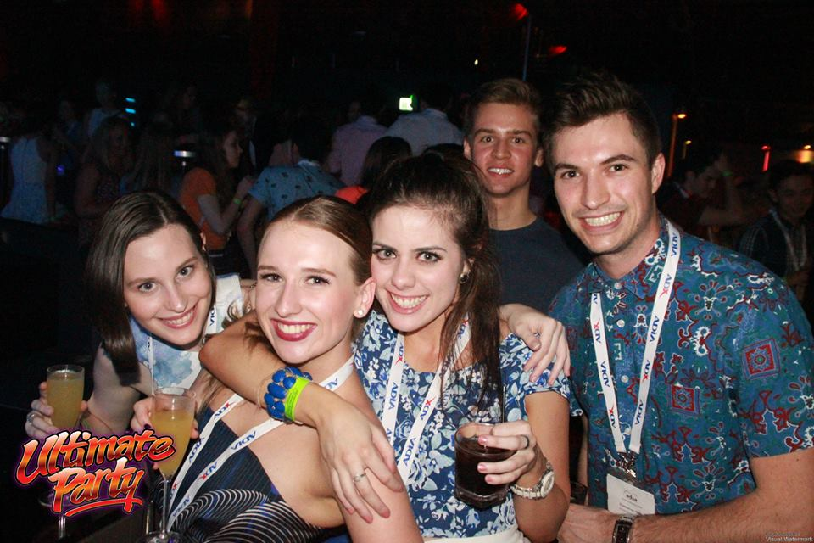
Delegates were treated to nothing but sunshine and warmth on arrival in Cairns. As check in began at the Novotel Oasis Resort Cairns, students started to realize that this was going to be a convention like no other. In classic JCU-dental-student-style, it was decided the best way to introduce the delegates to Cairns was by throwing them on the Ultimate Party Bus. I’m sure I speak on behalf of the majority when I say this was the craziest Tuesday night I’ve ever had. From inter-university competitions that guaranteed a smile to dance offs that showed everyone’s inner Beyonce, it really was a great start to the week.
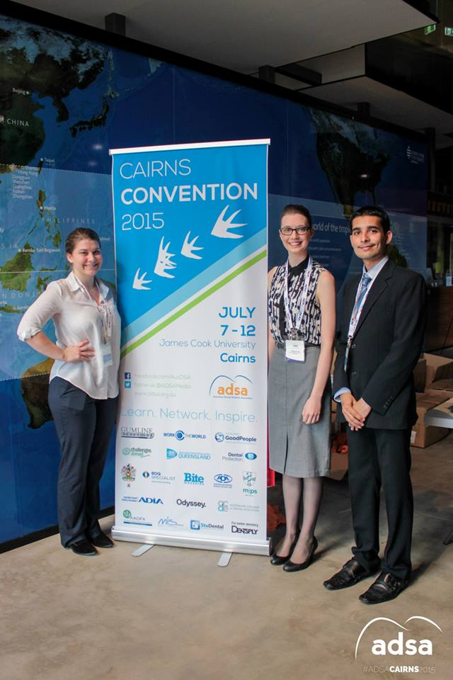
Wednesday morning saw an impressive turn out at James Cook University for the first day of lectures and workshops. Highlights from the day include streamed seminars from Professor Alan Nimmo (JCU) on The Role of Inflammation in Oral and Systemic Disease and recent graduate experiences from Dr. Louise Hanrahan, Dr. Shelby Harris and Dr. Mike Chan (all JCU graduates). The hands-on implants workshop for dental students presented by MIS Implants was definitely a crowd pleaser.

To keep the party rolling, Wednesday night was Rumble in the Jungle at the Woolshed. Students donned anything from a monkey onsie to simply leaves covering the essentials for a night of fun, dance and friendship. Students broke away from their usual university packs and really got to know one another in the entertaining jungle that is the Woolshed Cairns.
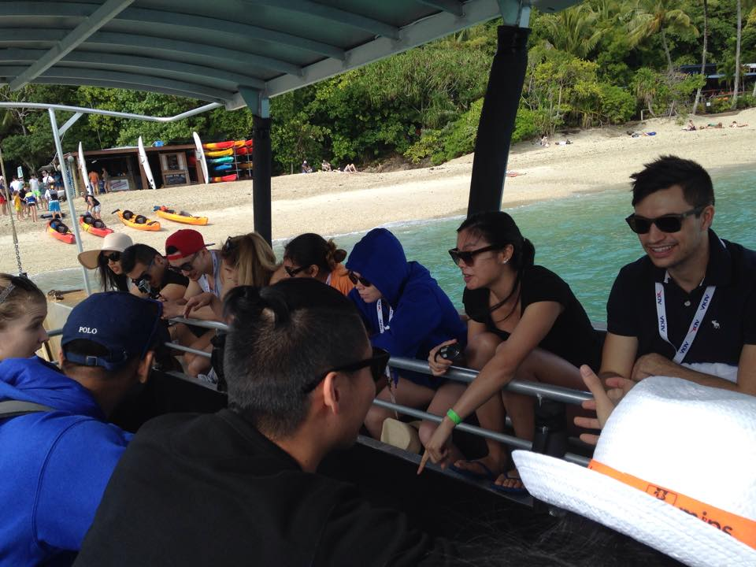
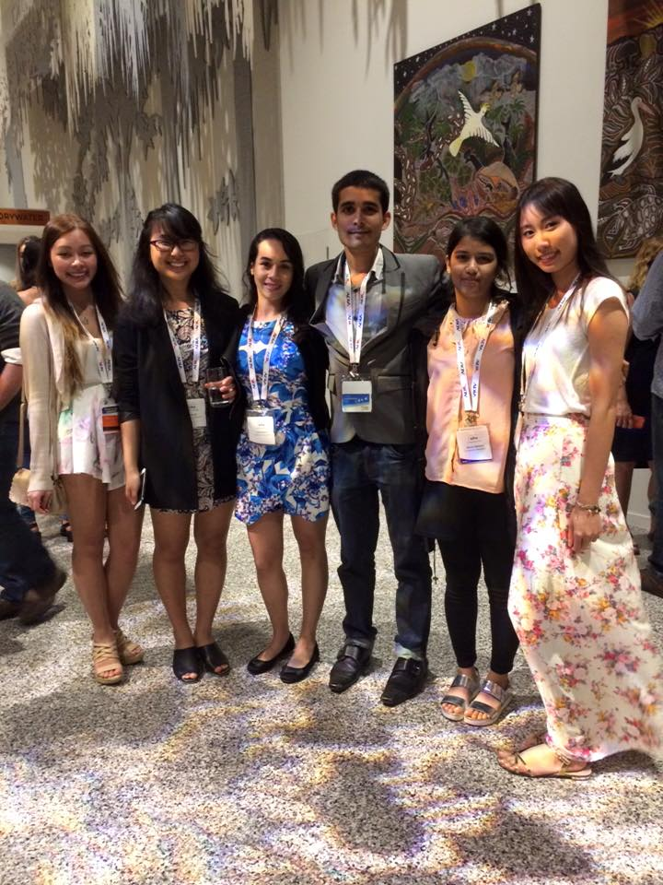
There was no time to rest on Thursday, as it was time to hit up Fitzroy Island for an ADSA Convention exclusive. Departing Cairns bright and early, students had no idea what they were in for. To say the boat ride over was rough is the understatement of the Convention. Rain, wind, waves and pre-partied dental students was not a pleasant combination. Nevertheless, 45 minutes later we arrived to sun, sand and the Great Barrier Reef. Students had the opportunity to snorkel, paddleboard, kayak and even jump on an ocean trampoline. It truly was a magical day for all.

The magic didn’t end there. Thursday night saw another ADSA Convention exclusive at Tjapukai Aboriginal Cultural Park. Students had time to relax and unwind after a day at the reef with the world-renowned interactive show presented by the talented traditional Tjapukai dancers. Learning traditional Aboriginal dance and song followed by a 4-course buffet meal left many students glad they booked their tickets to Cairns.

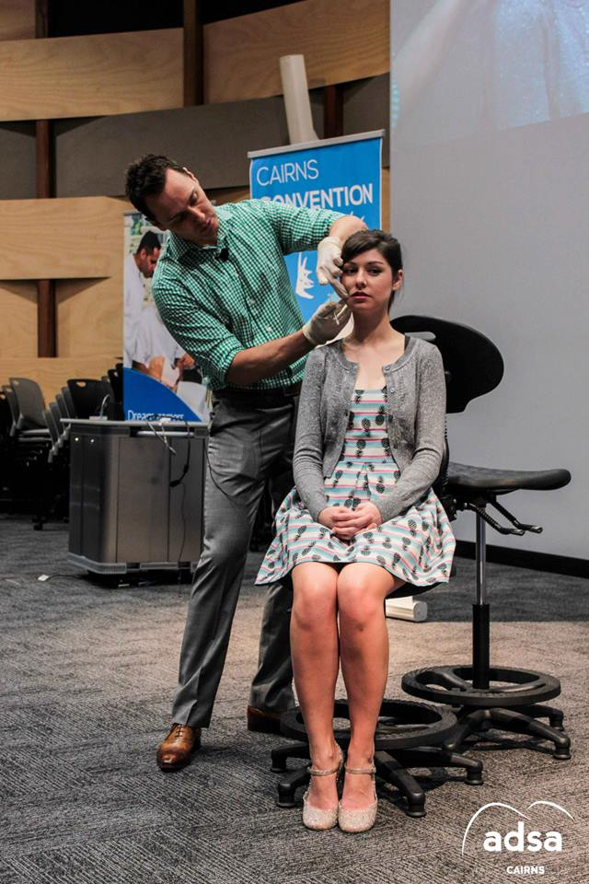
Friday morning, fresh-faced delegates were treated to an Outback Dental Experience from Associate Professor Robyn Boase (JCU). Many students agree that highlights from the Friday morning include Dr. Sheng Zhang’s (MIPS) presentation on Indemnity Case Studies of Recent Graduates and the Essential of Periodontics as a Young Graduate from Dr. Brian James (Cairns).

The real star of the day however was Dr. Myles Holt, Director of Australiasian Academy of Dento-Facial Aesthetics (AADFA) and his presentation on Dento-Facial Aesthetics. With a live demonstration on the use of Botox and dermal fillers, many students were in awe of this exciting advancement in the dental profession. This was the first time an ADSA Convention had hosted such a seminar.

If students were worried the fun was over, Friday night proved them wrong. Recess – Back to School theme – saw students rekindle at the Pier Bar and then break it down at Lyquid Night Life. For many, this was a school night with reports some delegates were in bed by 9pm; I wonder who that could have been?

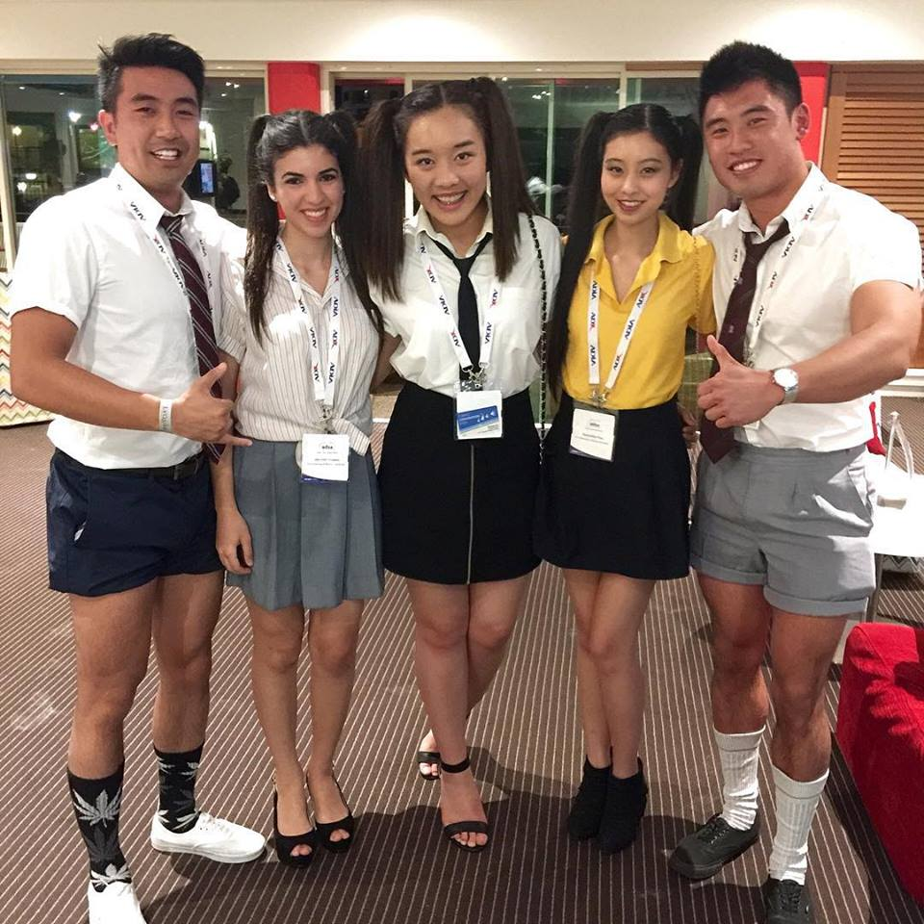

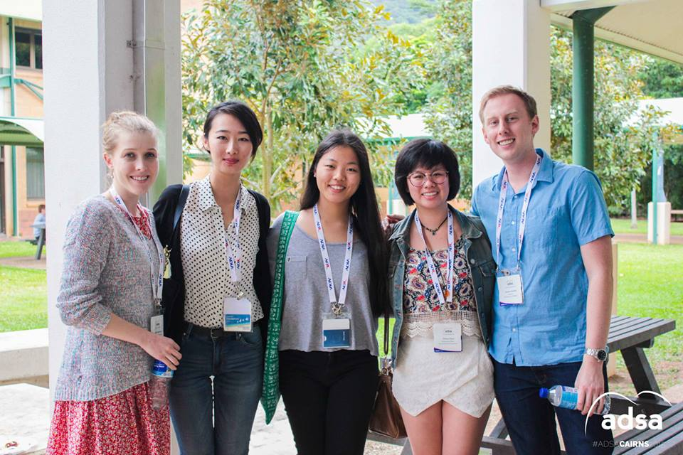
Saturday was bittersweet; students were excited for the Trade Show but disappointed that this was their last official day of Cairns Convention 2015. To kick the day off, Odyssey Specialist Group, Challenges Abroad, Around Good People and the National Dental Foundation spoke on their various opportunities for dental students. It was difficult to decided on which streamed seminar to choose: Dr. Rhonda Coyne’s (Cairns) Orthodontics of Today and Professor Bob Jones’ (JCU) Modern Technology in Oral and Maxillofacial Surgery were equally inspiring.

To conclude what was an exhausting and exhilarating week, a Twilight Cocktail Party took place at the Hilton Cairns. In black and white theme, delegates were treated the sumptuous hors-doeurves and were enveloped by the effervescence of the numerous refreshments. Despite some delegates wishing to get their ‘Magic Mike’ on, everyone had a wonderful evening.

On behalf of Michelle and the entire ADSA Cairns Convention committee, it truly was a pleasure to organize and participate in such an amazing experience with you all. Special thanks must be made to the ADSA President, Mohit, and the ADSA committee including, James (Treasurer), Cherie (Sponsorship Officer), Cheryl (Publications Officer) and Nicole (Media and Communications Officer).

Michelle and I wish the 2016 ADSA Convention co-conveners all the best of luck and we cannot wait to see you all on the dance floor sometime soon.

